Link Maestro is a rewrite of the Copy Link command. In addition to the default functionality, Link Maestro adds the ability to link to a web client page. It can also do multi-site links, which is where each Vault site gets it's own link. For Vault Professional users, you can now create Item and Change Order links.
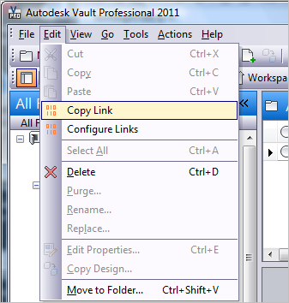
Requirements:
- Vault Workgroup/Collaboration/Professional 2011
Some features may not work depending on the Vault product.
Click here to download the application
Click here to download the source code
To use:
Run the install and start Vault Explorer.
Under the Edit menu, select Configure Links. A dialog will pop up allowing you to select what link format you want for each object type.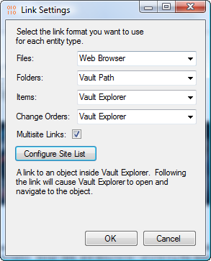
Multi-site links require that an administrator first set up the list of sites.
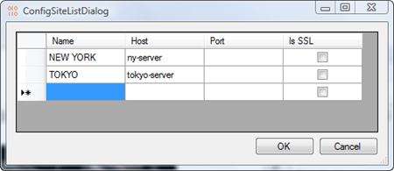
Using Web Browser links:
I do not recommend storing links to web client pages. These links are not designed for long term use. First they link to a specific version. So as time goes on, the link will go out of date. Or the version could get purged, which will break the link. Next, the link syntax may change in future release.
Web browser links work best for short term use, such as sending an email to a colleague with a download link.
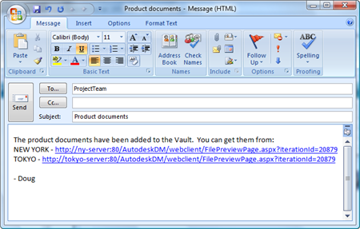
As with all the samples on this site, the legal disclaimer applies.

